# AMERICAN SIGN LANGUAGE DETECTION USING LSTM

A project report submitted for the partial fulfillment of the Bachelor of Technology Degree in

**Computer Science & Engineering under Maulana Abul Kalam Azad University of Technology**

**Debopriya Dutta**

Roll No: 22021002002034, Registration Number: 211040100120008

**&**

**Sumit Panja**

Roll No: 22021002002020, Registration Number: 211040100120033

Academic Session: 2020-2024

Under the Supervision of Associate Professor,

Dr. Prithwineel Paul



**Department of Computer Science and Engineering Institute of Engineering & Management**

Y-12, Salt Lake, Sector 5, Kolkata, Pin 700091, West Bengal, India Affiliated To

**Maulana Abul Kalam Azad University of Technology**

BF 142, BF Block, Sector 1, Kolkata, West Bengal 700064

**May 2024**

# 

**CERTIFICATE**

***TO WHOM IT CONCERNS***

This certificate confirms that the project report titled **“AMERICAN SIGN LANGUAGE DETECTION USING LSTM”**, presented by **DEBOPRIYA DUTTA** **Roll: 22021002002034**, **SUMIT PANJA Roll: 22021002002020** from the **Institute of Engineering & Management** for their **Bachelor of Technology degree** in **Computer Science & Engineering** is a genuine work undertaken during the final academic year, under supervision of **Prof. Dr. Prithwineel Paul**. The content of the report has not been previously submitted elsewhere for any other degree. It is also attested that the work is original and the performance satisfactory.

**Prof. Dr. PRITHWINEEL PAUL**

Assistant Professor

Department of Computer Science and Engineering

Institute of Engineering & Management

**Dr. MOUTUSHI SINGH**

Head of the Department

Department of Computer Science and Engineering

Institute of Engineering & Management

**Dr. ARUN KUMAR BAR**

Principal

Institute of Engineering & Management

# AMERICAN SIGN LANGUAGE DETECTION USING LSTM

### INSTITUTE OF ENGINEERING & MANAGEMENT



#### DECLARATION

**FOR NON-COMMITMENT OF PLAGIARISM**

We, Debopriya Dutta, Sumit Panja, students of B.Tech in the Department of Computer Science and Engineering, Institute of Engineering & Management have submitted the project report in partial fulfillment of the requirements to obtain the above noted degree.

We declare that we have not committed plagiarism in any form or violated copyright while writing the report and have acknowledged the sources and/or the credit of other authors wherever applicable. If subsequently it is found that we have committed plagiarism or violated copyright, then the authority has full right to cancel/reject/revoke our degree.

Name of the Student: **DEBOPRIYA DUTTA**

Full Signature:

Name of the Student: **SUMIT PANJA**

Full Signature:

Date:

### DEDICATION

I wish to express my deepest gratitude by dedicating this thesis to my beloved family, whose boundless love, unwavering support, and countless sacrifices have been the cornerstone of my journey. Your enduring belief in me has been the driving force behind every triumph and milestone achieved. Your constant encouragement and understanding have provided me with the courage to persevere through challenges and pursue my academic endeavors with unwavering determination.

To my dear friends, who have stood by my side through thick and thin, I extend my heartfelt appreciation for your unwavering friendship, unwavering support, and unwavering laughter that has illuminated even the darkest of days. Your camaraderie and companionship have enriched my life in countless ways, filling it with joy, warmth, and unforgettable memories. I am profoundly grateful for your presence in my life and for the unwavering support you have shown me throughout this journey.

In dedicating this thesis to my family and friends, I honor the profound impact you have had on my life and the invaluable role you have played in shaping the person I am today. Your love, encouragement, and unwavering belief in me have been my greatest blessings, and for that, I am eternally grateful.

## ACKNOWLEDGEMENT

We would like to express our sincere gratitude for the generous support and guidance we have received throughout the development of our project. Our American Sign Language Detection system using LSTM would not have been possible without the contributions of many dedicated individuals.

Our deepest appreciation goes to **Dr. Moutushi Singh**, Head of the Computer Science and Engineering Department, for her exceptional assistance during the project's implementation. Her expertise and commitment were indispensable to our success.

We are truly indebted to Associate **Professor Dr. Prithwineel** **Paul** for his unwavering support, mentorship, and insightful feedback. His dedication to our project, along with his ability to identify challenges and offer solutions, significantly propelled us forward.

Additionally, we would like to acknowledge the valuable contributions of the entire CSE department faculty for their advice and support, and the supporting staff for their dedication to providing the necessary resources.

……………………..........

(Signatures)

………………………………….. (Name and Roll no of the student(s))

Date:

**TABLE OF CONTENTS**

Article No. Content Page No

1. ABSTRACT 2
2. [CHAPTER-1] INTRODUCTION 3 - 7
3. **[CHAPTER-2] LITERATURE REVIEW 8 - 9**
4. [CHAPTER-3] URL DIAGRAM 10 - 12
5. [CHAPTER-4] MATERIAL AND METHODS 13 - 17
6. **[CHAPTER-5] LSTM ARCHITECTURE 18 - 24**
7. **[CHAPTER-6] TRAINING PROCESS 25 - 33**
8. **[CHAPTER-7] EXPERIMENTAL ANALYSIS & RESULT 34 - 43**
9. **[CHAPTER-8] DISCUSSION AND CONCLUTION 44**
10. **[CHAPTER-9] SUMMARY AND FUTURE WORK 46 - 46**

## ABSTRACT

Effective communication is essential for all individuals, and those with hearing impairments often rely on sign language. This project presents a novel system for real-time sign language detection designed to bridge communication barriers.

The system leverages Media Pipe’s advanced hand-tracking capabilities to isolate key landmarks within video frames obtained via OpenCV. These landmarks are then analyzed by a sophisticated Long Short-Term Memory (LSTM) Recurrent Neural Network model, built with TensorFlow, that understands both the spatial and temporal dynamics of sign language gestures.

The outcome is a robust system capable of translating sign language input into a more broadly understood format. This project holds significant potential to enhance accessibility and communication for the deaf and hard-of-hearing community.

**Key Points:** TensorFlow, Media Pipe, ASL Detection, LSTM Networks, Machine Learning, Python

### Chapter-1 INTRODUCTION

#### INTRODUCTION

#### Sign language, a visually-driven language with its own grammar and structure, serves as a vital communication channel for the deaf and hard-of-hearing community. Unfortunately, a lack of widespread sign language understanding often hinders interaction with those who primarily rely on spoken language. This project aims to bridge this communication gap through the development of a real-time sign language detection system.

#### Our system leverages the power of cutting-edge technologies:

#### Media Pipe:

#### Media Pipe serves as the foundation for visual understanding in this system. This open-source framework analyzes the video stream and extracts critical hand landmarks. These landmarks encode the intricate shapes and positions of the hands, providing the essential data for sign interpretation.

#### Long Short-Term Memory (LSTM) & Recurrent Neural Network (RNN):

#### The heart of our system's understanding lies in a specialized deep learning model, a Long Short-Term Memory (LSTM) Recurrent Neural Network (RNN) built with TensorFlow. This model is particularly adept at identifying patterns within sequences. It analyzes the hand landmark sequences provided by Media Pipe, learning the subtle changes and movements that distinguish different signs over time.

#### OpenCV:

#### OpenCV, a renowned computer vision library, offers multifaceted support for this system. It handles the essential tasks of capturing the video stream and provides tools for any necessary image manipulation.

#### By harnessing the power of these tools, this project aims to dismantle communication barriers frequently faced by the deaf and hard-of-hearing community. Our system will translate the expressiveness of sign language into a readily accessible format. This advancement promotes greater understanding and empowers those who rely on sign language to engage with the world around them more freely.

#### PROBLEM STATEMENT

#### Sign language, a vibrant and expressive mode of communication, remains largely inaccessible to the broader hearing population. This linguistic barrier creates significant challenges for deaf and hard-of-hearing individuals, limiting their ability to fully engage in social settings, access essential information, and participate in many spheres of everyday life.

#### While human sign language interpreters offer a solution, they can be scarce or costly, making them impractical for many everyday interactions. Moreover, text-based communication may not fully capture the nuances of sign language for those who rely heavily on visual expression.

#### A pressing need exists for a readily available, intuitive, and technologically advanced solution that facilitates effortless communication between the deaf and hard-of-hearing community and those who don't understand sign language.

#### SIGN LANGUAGE DETECTION SYSTEM

#### Imagine a system that can effortlessly "see" and understand sign language. Our system begins with OpenCV, functioning as its eyes, capturing a live video stream. Then, Media Pipe meticulously analyzes each video frame, pinpointing the intricate positions of hands and fingers. This generates a dynamic sequence of hand landmark data.

#### The heart of the system lies in an advanced LSTM RNN model, meticulously trained on a diverse dataset of sign language gestures. This model analyzes the patterns and movements of the hand landmarks over time, deciphering their meaning. When a sign is recognized, the system seamlessly translates it into text or another accessible format, effectively opening up a world of communication possibilities.

#### IMPACT OF THE PROBLEM

#### The communication challenges faced by the deaf and hard-of-hearing community create barriers that extend far beyond interpersonal interactions. In our increasingly technology-driven world, this disconnect can significantly impact access to information and participation. Deaf and hard-of-hearing individuals may face difficulties understanding video content without captions or sign language interpretation, engaging fully in video conferencing platforms, and navigating modern voice-controlled devices and interfaces.

#### LIMITATIONS OF EXISTING SOLUTION

#### While solutions like sign language interpreters are invaluable, they often face limitations of availability and cost. This creates obstacles in everyday interactions, hindering spontaneous conversations and making communication support impractical in many settings.

#### Additionally, text-based communication, though widely used, presents its own challenges. It can be a slow and less expressive alternative for deaf and hard-of-hearing individuals accustomed to the visual richness of sign language. Moreover, those who don't know sign language may struggle to convey their intended meaning with the same fluidity and nuance through text alone.

#### IMPACT ON INDUSTRY AND SOCIETY

#### Media Pipe’s powerful holistic models possess transformative potential across sectors and within society at large. In the healthcare field, they pave the way for enhanced physical therapy monitoring, more accessible remote consultations, and precision analysis of medical imaging. Within the realm of education, Media Pipe can empower interactive learning experiences, facilitate sign language translation in virtual classrooms, and enable real-time feedback on physical skill development. The entertainment industry stands to benefit from augmented reality experiences, immersive games, and novel interactive storytelling formats. Ultimately, Media Pipe democratizes the use of advanced computer vision solutions, propelling technological innovations that address diverse needs, enhance accessibility, and improve lives.

* 1. **PROJECT GOALS**
     1. **REAL-TIME TRANSLATION:** A core objective of this project is to develop a system capable of recognizing and translating sign language gestures in a manner that mirrors the pace of natural conversation. The system will analyze signs as they are performed and seamlessly convert them into a chosen format (like text or synthesized speech). This focus on real-time functionality will foster more fluid and intuitive communication.
     2. **POTENTIAL APPLICATIONS:** This project aims to bridge communication gaps by providing real-time translation between sign language and other accessible formats. Beyond interpersonal communication, this technology has far-reaching potential. It could make educational settings more inclusive for deaf and hard-of-hearing students, enhance accessibility within video conferencing platforms, and even serve as an innovative sign language learning tool.
     3. **FUTURE GOALS**

A key future goal of this project is to prioritize a highly intuitive and user-friendly design. The aim is to make the system easily accessible and navigable for deaf and hard-of-hearing users, regardless of their level of technical experience. This might involve simple interfaces, clear visual instructions, and the potential for customization based on individual needs.

This project focuses on the development of a dynamic sign language detection system capable of translating signs into text in real time. The emphasis is on creating an intuitive, user-centered system that has the potential to significantly improve communication accessibility and understanding for the deaf and hard-of-hearing community.

* 1. **TARGET AUDIENCE**
     1. **PRIMARY TARGET AUDIENCE**

This system is designed explicitly for deaf and hard-of-hearing individuals who use sign language as their primary mode of communication. The goal is to create a technological bridge that facilitates effortless conversation and understanding between sign language users and those who do not sign.

**1.8.2 SECONDARY TARGET AUDIENCE**

This system also holds value for educators, providing real-time captioning for deaf and hard-of-hearing students and fostering a more inclusive classroom experience. Additionally, it can enhance communication for professionals such as healthcare providers, social workers, and others who interact with the deaf and hard-of-hearing community.

**1.9 FUTURE DIRECTION**

The evolution of pose and gesture recognition technology will focus on achieving unparalleled accuracy, near-instantaneous processing, and seamless scalability across an immense range of applications. Media Pipe’s dedication to state-of-the-art machine learning and meticulously optimized algorithms positions it as a catalyst for these breakthroughs. Here's a glimpse into potential future developments:

* **Precision and Nuance:** Advancements in model architectures and training techniques will enable systems to recognize even the most subtle or complex gestures with unprecedented precision. This will empower applications requiring fine-grained control and expressive interaction.
* **Real-time Responsiveness:** Optimized algorithms paired with increasingly powerful hardware will push the limits of real-time processing. This will enable fluid, interactive experiences where the lag between gesture and system response becomes imperceptible.
* **Ubiquitous Integration:** Gesture recognition will transition from specialized systems to a core component of diverse devices and environments. Media Pipe’s flexibility will allow it to power this integration, enabling gesture control across smartphones, augmented reality interfaces, smart homes, and beyond.
* **Multi-modal Understanding:** Fusing visual data with inputs from other sensors (inertial measurement units, depth sensors, etc.) will unlock more robust gesture recognition. This multi-modal approach will enhance accuracy, particularly in challenging real-world conditions.
* **Personalized Interaction:** AI-powered personalization will enable systems to adapt to an individual user's signing style, body movements, and preferences. This will create a truly tailored, inclusive, and intuitive user experience.

Media Pipe is poised to be at the forefront of this technological transformation, propelling innovation in countless domains, and redefining how we interact with the digital and physical world.

**Chapter-2**

**LITERATURE REVIEW**

**2.1 SIGN LANGUAGE RECOGNITION SYSTEMS**

The field of sign language recognition (SLR) has experienced substantial growth and interest, fueled by its potential to fundamentally improve communication for deaf and hard-of-hearing individuals. SLR systems strive to decode the rich expressiveness of sign language, translating gestures into formats that bridge the communication gap with the hearing world. This section delves into the progression of SLR systems, examining key developments, diverse applications, and insights gleaned from the existing body of research.

**2.2 HISTORICAL PERSPECTIVE**

The quest to bridge the communication gap through sign language recognition began in the late 20th century. Initial efforts relied on early computer vision techniques to interpret gestures. A groundbreaking example is the wearable system designed by Starner et al. (1998), which captured hand gestures using specialized sensors. As the field progressed, researchers began to integrate machine learning algorithms for gesture recognition, a shift exemplified in the work of Vazquez et al. (2007).

**2.3** **MODERN APPROACHES IN SLR**

Sensor-based SLR leverages wearable technology embedded with sensors to track the precise movements and configurations of the hands. Recent advancements, like those highlighted in the work of Liu et al. (2019), demonstrate the potential of glove-based sensors to capture even intricate finger movements. This paves the way for real-time interpretation of complex sign language gestures. Moreover, research like that of Dahiya et al. (2020) explores cutting-edge sensor fusion techniques, where combining data from multiple sensors boosts the accuracy and robustness of SLR systems.

**2.4 VISION-BASED APPROACHES**

Vision-based SLR systems rely on the power of computer vision to analyze video data and understand the dynamics of sign language gestures. Pioneering work by Athitsos et al. (2008) established the feasibility of vision-based American Sign Language (ASL) recognition systems, paving the way for further innovation. The advent of deep learning has supercharged this field – research like that of Cao et al. (2021) demonstrates how powerful convolutional neural networks (CNNs) can excel at sign language recognition, achieving remarkable levels of accuracy.

**2.5** **DATA-DRIVEN APPROACHES**

Data-driven SLR systems depend on expansive datasets and sophisticated machine learning algorithms to learn the nuances of sign language gestures. The RWTH-PHOENIX-Weather 2014T dataset, introduced by Camgoz et al. (2017), has proven instrumental in developing deep learning models capable of interpreting continuous sign language. Furthermore, researchers like Pu et al. (2019) and Li et al. (2020) have successfully investigated the use of generative adversarial networks (GANs) to augment datasets. This technique boosts the diversity of training data, ultimately making SLR models more robust and adaptable to variations in signing styles.

**2.6 DEEP LEARNING IN SIGN LANGUAGE RECOGNITION**

The integration of deep learning has profoundly transformed sign language recognition (SLR) systems. These powerful techniques allow models to automatically extract meaningful features and decipher complex patterns directly from raw input data (whether sensor-based or visual). In this section, we'll examine how deep learning, particularly convolutional neural networks (CNNs) and recurrent neural networks (RNNs), drives innovation in SLR, referencing influential studies and key breakthroughs.

**2.7 CONVOLUTIONAL NEURAL NETWORKS (CNNS) FOR SLR**

CNNs excel at analyzing visual data, making them a natural fit for sign language recognition systems. Their ability to identify and extract meaningful spatial features from images has been groundbreaking. Research by Pu et al. (2016) showcased the power of CNNs when applied to depth images for accurate ASL gesture recognition. More recently, studies by Tran et al. (2021) and Zhang et al. (2022) have introduced innovative CNN architectures that incorporate attention mechanisms. These mechanisms allow the models to focus on the most crucial aspects of the visual sign language input, leading to even greater accuracy and nuance in interpretation.

**2.8 RECURRENT NEURAL NETWORKS (RNNS) FOR SLR**

RNNs, and specifically long short-term memory (LSTM) networks, shine in their ability to analyze sequences of data over time. This is crucial for sign language recognition, where the meaning of a gesture often depends on the flow of movements. Pioneering research by Graves et al. (2007) and Hochreiter and Schmidhuber (1997) established the potential of LSTM-based approaches. Building on this, these techniques are now successfully applied to continuous sign language recognition. Moreover, work by Wang et al. (2020) demonstrates the benefits of bidirectional LSTM networks, which can analyze sign sequences in both forward and reverse directions, incorporating a richer understanding of temporal context for improved accuracy.

### Chapter-3

### URL DIAGRAMS

### || Visualizing Systems for Clarity ||

UML (Unified Modeling Language) diagrams serve as the blueprints of software systems. Think of them as visual maps that illustrate the different components of a system, the relationships between them, and how users interact with everything. The goal of UML diagrams is to provide a clear, shared understanding of a system's design, promoting better development, maintenance, and communication about the project.

**3.1 CLASS DIAGRAM:**

Imagine a class diagram as the architectural plan for your software application. It lays out the fundamental building blocks – classes – that define your system's objects, their characteristics (attributes), and the ways they interact (operations). Class diagrams aren't just about the nitty-gritty code; they provide a conceptual, adaptable model of your system's structure.

The purpose of the class diagram can be summarized as: –

• Analysis and design of the static view of an application.

• Describe responsibilities of a system.

• Base for component and deployment diagrams.

• Forward and reverse engineering.

Class diagrams, a fundamental part of UML (Unified Modeling Language), offer several advantages:

**Visualization**: Class diagrams provide a visual representation of the structure and relationships within a system, making it easier to understand complex systems at a glance.

**Abstraction:** They help in abstracting complex systems, focusing on key entities (classes) and their interactions, simplifying the modeling process.

**Communication:** Class diagrams serve as a communication tool between stakeholders, enabling developers, designers, and non-technical stakeholders to discuss and understand system structure and behavior.

**Blueprint for Code:** They serve as a blueprint for code implementation, guiding developers in translating the design into executable code.

**Analysis and Design:** Class diagrams facilitate both system analysis and design, aiding in the identification of classes, their attributes, methods, and associations, contributing to a more systematic and organized development*.*

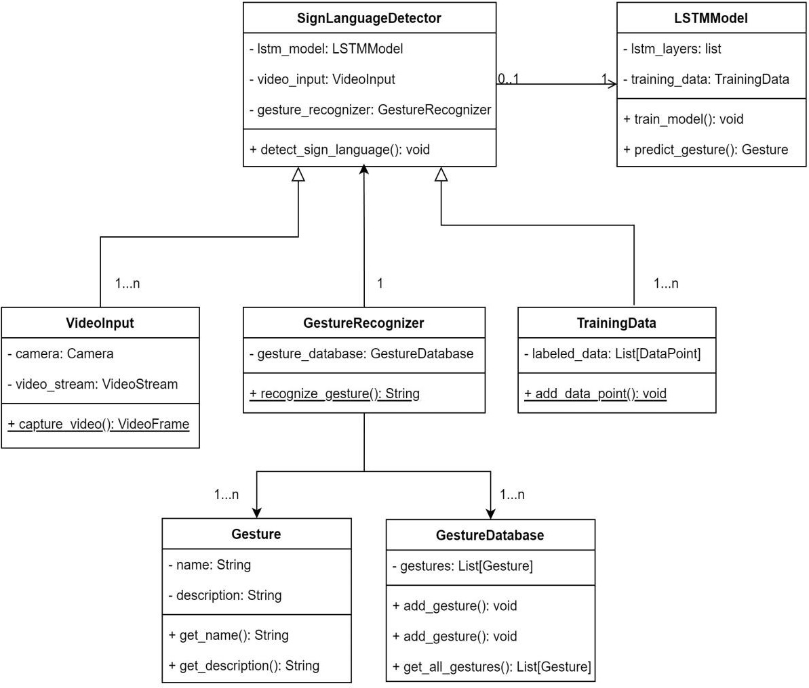

*Figure 1 Class Diagram*

**3.2 USE CASE DIAGRAM:**

UML (Unified Modeling Language) provides a diverse set of diagrams to visualize different aspects of software systems. Let's focus on use case, component, and deployment diagrams, which together illustrate user interactions, system composition, and real-world deployment.

Use case diagrams capture the user's perspective. They outline the specific actions a user can take within your system (use cases) and the relationships between users (actors) and those actions. Use case diagrams offer a simplified, high-level understanding of what your system should do, making it easier to grasp user requirements.

Component diagrams zoom in on the internal structure of your software. They break down your system into modular components, each representing a distinct functional unit. These diagrams illustrate how the various components connect and interact, promoting a well-organized and flexible design.

Deployment diagrams bridge the gap between software and the physical world. They depict the hardware (servers, devices, etc.) required to run your software components. This visualization helps plan the necessary infrastructure and ensures a smooth deployment process.

.

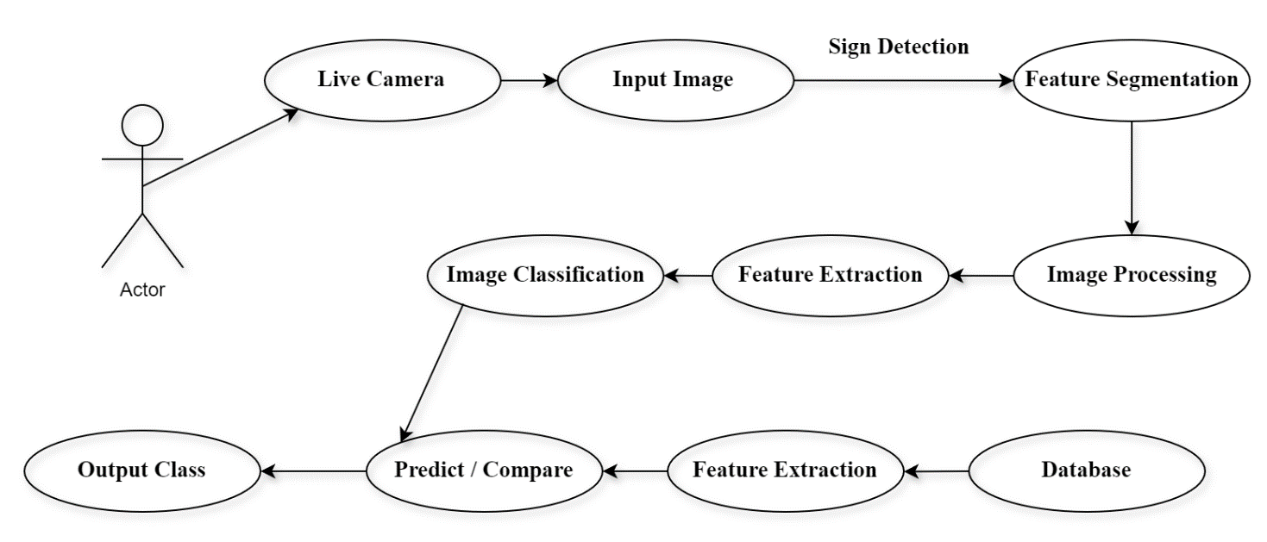

*Figure 2 Use Case Diagram*

### Chapter-4

### MATERIAL AND METHODS

**4.1 OVERVIEW OF THE PROJECT GOAL**

This project aims to create a robust gesture recognition system specifically designed to interpret sign language. Leveraging the power of Media Pipe for hand landmark detection and LSTM networks for recognizing temporal patterns, this system strives to bridge the communication gap between sign language users and non-signers.

**4.2 SYSTEM HARDWARE REQUIREMENTS**

To develop and run this sign language recognition system, you'll need the following:

* **Visual Input:** A webcam with sufficient resolution for clear hand tracking is crucial.
* **Processing Power:** A computer with a capable CPU is essential. For optimal performance and smooth real-time interpretation, consider a computer equipped with a dedicated GPU.
* **System Compatibility:** Ensure your operating system (Windows, macOS, Linux) supports the necessary software libraries and development tools.

**4.3 SOFTWARE REQUIREMENTS**

* **Programming Backbone:** Python serves as the primary programming language for this project.
* **Core Libraries:**
  + **OpenCV:** For image processing and computer vision tasks.
  + **Media Pipe:** For hand landmark detection.
  + **TensorFlow/Keras:** To build the LSTM deep learning model.
  + **Matplotlib/NumPy:** For data visualization and mathematical computations.

**4.4 DATA COLLECTION AND PREPROCESSING**

**4.4.1 DATA RECORDING PROCESS:**

**4.4.1.1 GESTURE SET DESIGN:** Define a set of distinct hand gestures.

**4.4.1.2 PARTICIPANT RECRUITMENT**: Recruit participants with diverse hand shapes and sizes.

**4.4.1.3 RECORDING INSTRUCTIONS:** Provide clear instructions on gesture execution.

**4.4.1.4 RECORDING CONSISTENCY:** Maintain a consistent distance between participant and camera.

**4.4.1.5 RECORDING VARIATIONS:** Capture variations in speed, hand orientation, and background (optional).

**4.4.2 DATA LABELING:**

* Utilize video editing software or labeling tools for frame-by-frame annotation.
* Ensure accurate labeling by assigning a clear gesture label to each frame.

**4.4.3 DATA PREPROCESSING:**

**4.4.3.1 MEDIAPIPE POSE ESTIMATION:**

* Import the `mediapipe` library and set up a holistic model for face, pose, left & right-hand estimation.
* Process each video frame to extract keypoint information (3D coordinates and visibility score).

**4.4.3.2 NORMALIZATION:**

* Normalize the extracted keypoints to a fixed range (e.g., 0 to 1).

**4.4.3.3 SEQUENCE SEGMENTATION:**

* Segment video data into sequences of a fixed length representing gestures.
* Use a sliding window approach to create multiple sequences from a single recording.
* Discard incomplete sequences at the beginning and end of the video.

**4.5 MODEL DEVELOPMENT:**



*Figure 3 Steps in model development*

**4.5.1 MODEL ARCHITECTURE:**

* Design a sequential neural network model using TensorFlow or Keras.
* Utilize LSTM layers to capture temporal relationships between keypoints in a sequence.
* **EXAMPLE ARCHITURE:**
* Start with LSTM layers with a moderate number of units (e.g., 64).
* Use Leaky ReLU activation functions throughout the model.
* Add a final Dense layer with a SoftMax activation for multi-class classification.

**4.5.2 MODEL TRAINING:**

**4.5.2.1 DATA SPLITTING:**

* Divide the preprocessed data into training, validation, and testing sets.

**4.5.2.2 TRAINING PROCESS:**

* Compile the model with an optimizer (e.g., Adam), a loss function (e.g., categorical crossentropy).
* Train the model for a specified number of epochs while monitoring training and validation loss.
* Employ early stopping to prevent overfitting.

**4.5.2.3 METRICES AND EVALUATION:**

* Track metrics like accuracy, precision, recall, and confusion matrix during training and evaluation.
* Evaluate the model's performance on the testing set for generalizability.

**4.6 REAL TIME GESTURE RECOGNITION:**

**4.6.1 REAL-TIME KEYPOINT EXTRACTION:**

* Continuously process frames from the live video stream through the Media Pipe model.

**4.6.2 GESTURE PREDICTION:**

* Convert the extracted keypoints into a sequence format compatible with the model.
* Feed the sequence into the trained model to predict the most likely gesture.

**4.6.3 VISUALIZATION AND OUTPUT:**

* Overlay the predicted gesture label on the live video stream.
* Optionally, trigger pre-defined actions based on recognized gestures.

**4.6. CONCLUSION:**

* Summarize key findings, accuracy, limitations, and areas for improvement.
* Discuss trade-offs between factors like accuracy, real-time performance, and computational efficiency.
* Explore future directions (e.g., incorporating more gestures, improving robustness, multi-hand recognition).

**4.7 ADDITIONAL CONSIDERATIONS FOR A ROBUST SYSTEM:**

**4.7.1 Data Augmentation**: Expanding your dataset is crucial for a system that works well in the real world. Beyond simple flipping and rotation, consider:

* **Synthetic Data:** Use 3D modeling tools to generate realistic hand poses in diverse lighting conditions and against various backgrounds.
* **Noise and Distortion:** Train your model to handle real-world imperfections like blur or slight occlusions by adding these elements artificially to your training data.

**4.7.2 Background Subtraction:** Complex environments can confuse gesture recognition systems. Techniques for isolating the hand region include:

* **Color-Based Segmentation:** Define a color range corresponding to skin tones for easier separation.
* **Motion Tracking**: Track differences between frames to focus on the moving element (likely the hands).

**4.7.3 Real-Time Performance** Optimization: Smooth interpretation requires careful attention to:

* **Efficient Algorithms**: Choose computationally efficient techniques within your processing pipeline.
* **Model Size**: Experiment with smaller model architectures for faster inference times.
* **Hardware Acceleration**: Utilize the power of GPUs or specialized AI acceleration hardware if available.

**4.7.4 Error Handling and User Feedback A system that gracefully handles uncertainty is key. Consider:**

* **Confidence Thresholds:** Allow users to adjust the sensitivity of recognition, potentially asking for confirmation on lower-confidence gestures.
* **Clear Visual Cues:** Indicate to the user when the system is unsure or if a re-sign is needed

**4.7.5 Ethical Considerations: Proactive steps ensure your system is inclusive and respects user privacy:**

* **Diverse Dataset:** Build a dataset reflecting a wide range of skin tones and sign language variations to minimize bias.
* **Consent and Privacy:** Clearly communicate data collection practices and give users control over their data.

**Chapter-5**

**LSTM ARCHITECTURE**

**5.1 MEDIAPIPE HOLISTIC:**

**A Comprehensive Vision Framework**

MediaPipe, an open-source framework from Google, offers a suite of powerful machine learning solutions for tasks like human pose, hand, and facial landmark detection. The Holistic model within MediaPipe takes this a step further, seamlessly integrating these capabilities into a single tool for full-body understanding.

**Key Features:**

* **Holistic Tracking:** Instead of focusing on isolated parts of the body, the Holistic model can simultaneously track a vast array of keypoints:
  + **Face:** 468 landmarks for detailed facial mapping.
  + **Pose:** 33 keypoints outlining the position of major joints.
  + **Hands:** 21 landmarks per hand, capturing intricate finger positions.
* **Efficiency and Accuracy:** MediaPipe Holistic is designed for both real-time performance and precise keypoint detection, crucial for real-world applications.

**5.2 KEYPOINT EXTRACTION:**

After MediaPipe Holistic identifies the body, hands, and face within a video frame, it goes deeper. For each keypoint, it provides:

* **Spatial Coordinates (x, y, z):** These values pinpoint the precise 3D location of each landmark, forming a skeletal map of the person.
* **Visibility Score:** This confidence measure reveals how certain the model is about the accuracy of a particular keypoint's location. This is especially important when dealing with potential occlusions or complex poses.

**5.3 ACTION CLASSES:**

Think of action classes as the target vocabulary that your system will learn to understand. They consist of distinct movements and gestures that your system is designed to recognize. Here's what's key about action classes:

* **Clarity is Crucial:** Choose actions that are easily differentiable based on hand movements, body posture, and even facial expressions. This helps the model learn distinct patterns.
* **Tailored to Your Goals:** In the context of sign language, your action classes would consist of individual signs.
* **Impact on Model Design:** The number of action classes you define directly influences the structure of your LSTM model's output layer (the part responsible for making the final prediction).

**5.4 SEQUENCE CLASS:**

In understanding actions, context is key. A single static image often isn't enough. Sequence classes define how your system breaks down a video stream into meaningful chunks for analysis. Consider them as the "filmstrips" your model examines:

* **Window Size Matters:** The number of video frames in each sequence dictates how much movement the model sees at once. A shorter window might focus on subtle hand gestures, while a larger one could capture a full-body sign.
* **The Balancing Act:** Too short of a window and the model may miss crucial information about how a gesture unfolds. Too long, and your system might become computationally slow or struggle to pinpoint when an action begins and ends.

**5.5 DATA COLLECTION:**

A specialized script guides users through performing defined actions while capturing video. Simultaneously, MediaPipe Holistic extracts crucial keypoint data from each frame. This pairing of video and keypoint information forms our dataset, teaching our model to visually understand each action class.

**5.6 MODEL ARCHITECTURE:**

**5.6.1 INPUT LAYER:**

The model expects a 3D tensor with dimensions (sequence_length, number_of_keypoints, keypoint_features).

**5.6.1.1 SEQUENCE_LENGTH:** This is the chosen window size representing the number of video frames in a sequence (e.g., 30 frames).

**5.6.1.2 NUMBER_OF_KEYPOINTS**: This depends on the MediaPipe Holistic configuration and typically refers to the total number of keypoints extracted from the body, hands, and face (e.g., 512 for full body pose, hands, and face).

**5.6.1.3 KEYPOINT_FEATURES:** This represents the dimensionality of each keypoint, which is typically 4, including the x, y, z coordinates, and the visibility score (0-1).

**5.6.2 STACKED LSTM’S:**

LSTMs have a superpower for handling sequences: they remember! Unlike traditional neural networks that look at inputs independently, LSTMs maintain a "memory" of past information, crucial for understanding how actions unfold over time.

* **Building Layers of Understanding:** Our model stacks multiple LSTM layers. Each layer adds depth – it analyzes the output of the previous layer, learning increasingly complex patterns within the keypoint sequences.
* **Neuron Power:** The units within each LSTM layer act like tiny pattern detectors. More units mean Our model has a larger toolkit to find subtle relationships within the data.
* **Key Parameters:**
  + **return_sequences**=**True** is essential for the first few layers, passing the entire history of patterns to the next layer for deeper analysis.
  + The final layer uses **return_sequences**=**False** to condense the entire sequence analysis into a single representation, ready for action classification.

**5.6.3 DENSE LAYERS:**

After the LSTM layers have done their work extracting patterns from the sequences, it's time for dense layers to step in. Think of them as the organizer:

* **Connecting the Dots:** Dense layers take the output from the LSTMs and link all the information together. Every neuron in a dense layer is connected to every neuron in the previous layer, allowing for complex interactions.
* **Dimensionality Control:** The number of units (neurons) in a dense layer lets you tweak how compact you want the representation to be. This helps the model focus on the most essential features for classification.
* **LeakyReLU: The Gradient Helper:** LeakyReLU activation functions prevent a common problem faced by RNNs – the "vanishing gradient" which makes learning difficult. LeakyReLU allows a slight flow of information even when inputs are negative, ensuring the model learns effectively.

**5.6.4 OUTPUT LAYER:**

The output layer is where our model translates its analysis into a concrete prediction. Consider it the final judge:

* **Matching Action Classes:** The number of neurons (units) in this layer directly corresponds to the number of actions our system is designed to recognize. Each neuron will represent a specific action class.
* **The Role of Softmax:** Softmax transforms the raw output values into probabilities. Think of these probabilities as "confidence scores" for each action. The action class with the highest probability becomes the system's final prediction.

**5.6.5 MODEL TRAINING:**

**5.6.5.1 ADAM OPTIMIZER:**

Imagine training your model is like navigating a complex landscape to reach the lowest point (which represents minimizing errors). Adam is like a sophisticated GPS system for this journey:

* **Adaptive Learning Rates:** Adam doesn't use a single learning rate for all parameters. Instead, it cleverly adjusts the learning rate for each individual weight based on past updates. This helps it navigate different areas of the landscape more efficiently.
* **Taming the Gradients:** Gradients guide the direction of updates. Adam helps manage them intelligently, preventing issues like getting stuck in valleys or wildly overshooting due to huge gradients.
* **Why Adam Works Well:** It combines the strengths of techniques like momentum-based optimization (for speed) and adaptive gradient methods (for adaptability). This makes it a powerful and versatile optimizer for many deep learning tasks.

**5.6.5.2 CATEGORICAL CROSSENTROPY LOSS:**

The loss function acts as your model's internal compass during training, telling it how far off its predictions are from the goal. Categorical cross-entropy is specifically designed for situations where you have multiple possible classes:

* **Comparing Predictions:** It compares the model's output (the probabilities from the Softmax layer) with the true label of an action. Remember, one-hot encoding provides a crystal-clear representation of the correct action.
* **Pinpointing Errors:** The larger the gap between the predicted probabilities and the true label, the higher the loss. This signal tells the model that it needs to make significant adjustments.
* **The Goal:** During training, the model constantly tries to minimize this loss. By doing so, its predictions become increasingly aligned with the true action labels, ultimately improving its accuracy.

**5.6.5.3 CATEGORICAL ACCURACY:**

While the loss function guides your model during training, categorical accuracy is the ultimate judge of how well it has learned its task. Think of it like the final exam:

* **Straightforward Measure:** Categorical accuracy is simple to understand. It tells you what percentage of actions the model correctly identified on the testing data.
* **Reality Check:** Monitoring accuracy on a dataset the model hasn't seen during training (your testing set) is crucial. This reveals how well it generalizes to new examples, helping you spot if it has overfit the training data.

**5.6.5.4 TRAINING AND TESTING DATA SPLIT:**

Think of splitting your dataset as creating two teams:

* **The Training Team:** This larger group (typically around 95% of your data) is where your model does all its learning. It studies the keypoint sequences and action labels, finding patterns and refining its predictions.
* **The Testing Team:** This smaller group (the remaining 5%) is held back until the model is fully trained. It serves as a "reality check." Can the model perform well on actions it hasn't encountered during training? This split prevents overfitting, where a model becomes overly specialized to the training data and performs poorly in real-world situations.

**5.6.6 MODEL INFERENCE:**

**5.6.6.1 REAL-TIME VIDEO INPUT:**

After the rigorous training phase is complete, it's time for your model to step out into the real world. Here's how real-time video input comes into play:

* **Shifting Gears:** Instead of analyzing pre-recorded datasets, the system now continuously processes live video data from a webcam or other source.

**5.6.6.2 KEYPOINT PREDICTION:**

For each frame of the incoming video, MediaPipe Holistic acts as your model's vision system. It meticulously analyzes the frame to locate and pinpoint the crucial body, hand, and facial landmarks.

**5.6.6.3 SEQUENCE BUFFER:**

Think of the sequence buffer as a sliding window that your model uses to view recent history. With each new frame:

* **New Data Arrives:** The fresh keypoint information calculated by MediaPipe is added to the buffer.
* **Window Slides:** The oldest keypoint data in the buffer is discarded to keep the window size fixed.
* **Maintaining Context:** This continuous update process ensures the model always has the most recent sequence of keypoints at its disposal, essential for understanding actions that unfold over time.

**5.6.6.4 MODEL PREDICTION:**

* **Seeking Patterns:** The LSTM layers analyze the flow of keypoints over time, searching for the distinct patterns it learned to associate with each action class.
* **The Final Verdict:** Based on these patterns and the probabilities generated by the output layer, the model makes its prediction of the action being performed.

**5.6.6.5 THRESHOLDING AND ACTION RECOGNITION:**

* **Confidence Check:** The thresholding system acts as a quality control filter. Actions only get recognized if the model's prediction for that action class has a probability above your chosen threshold. This helps reduce errors caused by uncertain classifications.
* **Seeking Stability:** Analyzing the last several frames add another layer of confidence. Consistent predictions over time increase the certainty that the action is being performed correctly.

**5.7 LSTM NEURAL NETWORK MODEL:**

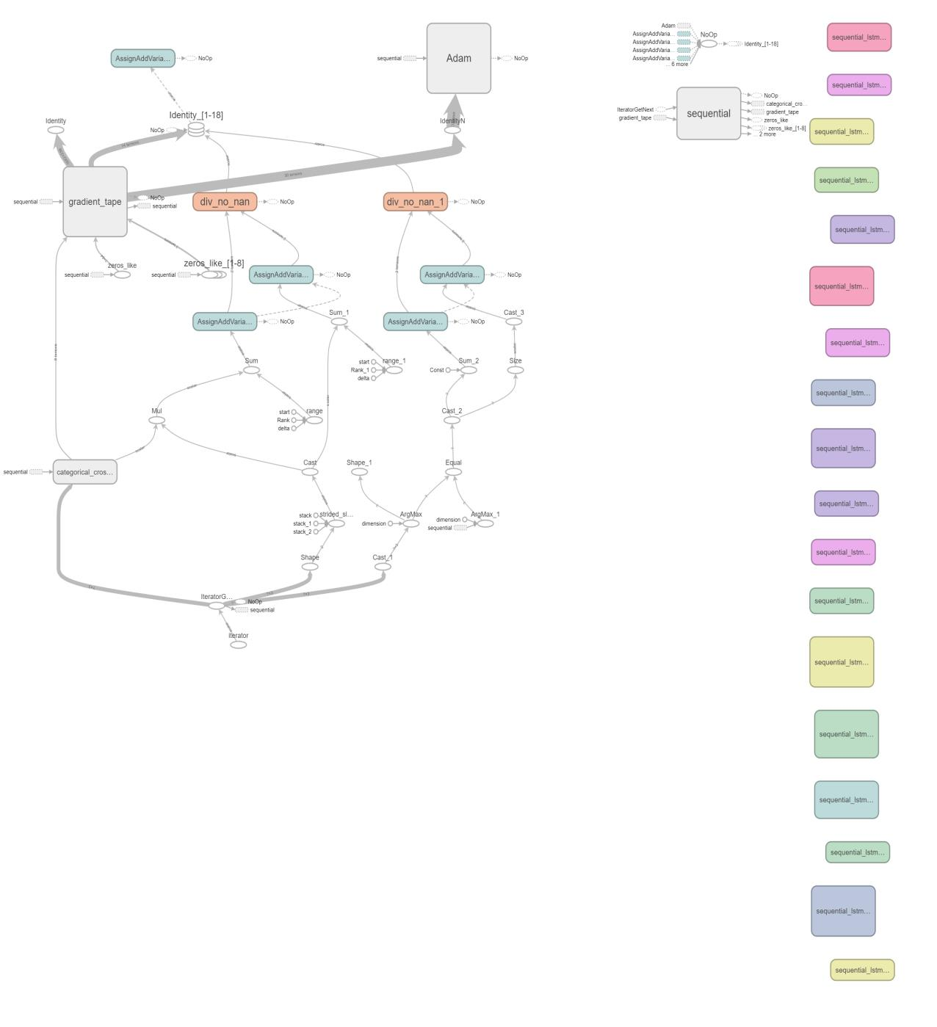

*Figure 4 Steps in Neural Network Model*

### Chapter-6

### TRAINING PROCESS

The training process for a machine learning model, such as one using LSTM architecture for sign language detection, involves several key steps:

**6.1 DATA COLLECTION AND PREPROCESSING:**

**6.1.1 DATA COLLECTION:**

**6.1.1.1 DATA SOURCES:** Gather data from multiple sources, including public datasets, custom recordings, and data augmentation techniques.

**6.1.1.2 ANNOTATIONS:** Ensure accurate annotations by employing multiple annotators and performing consensus checks to resolve discrepancies.

**6.1.1.3 METADATA:** Collect additional metadata such as timestamps, camera angles, and environmental conditions to facilitate data analysis and model interpretation.

**6.1.1.4 ETHICAL CONSIDERATION:** Address privacy concerns and obtain necessary permissions when collecting data involving human subjects.

**6.1.2 DATA PREPROCESSING:**

**6.1.2.1 IMBALANCED CLASSES:** If your dataset has some action classes that are much more common than others, your model risks becoming biased. It might get great at recognizing the frequent actions, but struggle with the rarer ones. Here are some techniques to combat this:

* **Oversampling:** Increase the presence of less frequent classes by replicating existing samples or carefully generating synthetic examples.
* **Under sampling:** Reduce the presence of the most dominant classes by strategically removing samples. This helps to balance the class distribution.
* **Class Weighting:** During training, assign higher importance (weight) to the minority classes. This forces the model to pay greater attention to examples that are underrepresented.

**6.1.2.2 DATA CLEANING:** Messy real-world data can throw a wrench into your model's training. Here's how to handle common issues:

* **Missing Values:** Gaps in your keypoint data can occur if MediaPipe fails to detect certain landmarks. Interpolation techniques can intelligently "fill in the blanks" based on surrounding data points.
* **Outliers:** Extreme values that don't fit the typical patterns might be due to errors. Outlier detection methods can flag these for removal or correction.
* **Corrupted Samples:** Sometimes entire video samples might be unusable due to poor lighting, blur, or other distortions. Data augmentation (generating variations of existing data) can help you replace these bad samples if necessary.

**6.1.2.3 FEATURE ENGINEERING:** While MediaPipe does an amazing job extracting keypoints, sometimes going deeper can boost your model's performance. Feature engineering lets you handcraft additional features tailored to your specific goal:

* **Domain Knowledge is Key:** Understanding how sign language works helps you decide what to extract. You might calculate distances between keypoints, angles between body parts, or speeds of hand movements.
* **Signal Processing Tools:** Techniques like smoothing to reduce noise, or transformations to highlight specific frequency patterns within the keypoint data can reveal hidden insights.

**6.1.2.4 DIMENSIONALITY REDUCTION:** High-dimensional data (lots of features) can be computationally demanding and sometimes even hinder your model's performance. Here's where dimensionality reduction techniques come in:

* **PCA (Principal Component Analysis):** PCA identifies the most important directions of variation in your data. By projecting your data onto a smaller set of these "principal components", you can reduce dimensionality while preserving much of the crucial information.
* **Autoencoders:** This type of neural network learns to compress data into a compact representation and then reconstructs it back. This forces it to prioritize the most essential features for accurate reconstruction.

**6.2 MODEL ARCHITECTURE:**

**6.2.1 LSTM MODEL:**

**6.2.1.1 MEMORY CELLS:** Your original model wisely uses LSTM cells, but it's worth exploring alternatives as they offer different strengths:

* **GRU (Gated Recurrent Unit):** Similar to LSTM, but structurally slightly simpler. GRUs can sometimes train faster or perform well with less data.
* **Bi-LSTM (Bidirectional LSTM):** These process sequences in both directions (forward and backward through time). Bi-LSTMs might excel if understanding both past and future context is crucial for recognizing certain signs.
* **Addressing Vanishing Gradients:** LSTMs and GRUs already have mechanisms to fight this problem, but severe cases might still occur in complex data.

**Experimentation is Key:** The best memory cell for your project depends on your specific dataset and the nuances of the signs you're recognizing. Try training models with each type and carefully compare their performance.

**6.2.1.2 TEMPORAL HIERARCHIES:** Some signs rely on quick, fine-grained hand movements, while others involve broader, full-body motions that unfold over longer time periods. Hierarchical models are designed to capture these different levels of detail:

* **The Layers:** Imagine a stack of LSTM networks where each layer analyzes the sequence at a different timescale.
  + Lower layers might focus on the rapid changes between adjacent frames, spotting small hand gestures.
  + Higher layers could look for patterns across a longer span of movement, identifying gestures that take more time to perform.

**6.2.1.3 ATTENTION MECHANISMS:** Think of attention mechanisms as giving your model a spotlight that it can shine on the most crucial parts of the keypoint sequence. Here's how it works:

* **Selective Importance:** Instead of treating all frames within the sequence equally, attention allows the model to dynamically assign higher weights to the frames that are most relevant for determining the action class.
* **Real-World Example:** For a sign focused on precise hand shapes, the model might learn to pay close attention to the frames where the hand is most clearly visible.

**6.2.2 COMPILATION:**

**6.2.2.1 LEARNING RATE POLICIES:** The learning rate controls how big of a step your model takes with each update in its search for the optimal solution. Instead of a single, fixed learning rate throughout training, custom policies can be surprisingly powerful:

* **Cyclic Learning Rates:** These policies periodically increase and then decrease the learning rate. This can help the model escape from local minima (getting stuck in sub-optimal areas) and converge more quickly.
* **Warm-Up Schedules:** Gradually increasing the learning rate at the start of training can help stabilize the process, especially for complex models.

**6.2.2.2 REGULARIZATION TECHNIQUES:** Overfitting is when your model becomes too specialized to the details of your training data and loses the ability to perform well on new examples. Regularization provides safeguards:

* **Dropout:** Randomly "turning off" some neurons during training forces the model to learn redundant representations. This makes it less reliant on specific patterns and more likely to generalize well.
* **Batch Normalization:** This smooths out the flow of data within the model during training. It can help reduce sensitivity to certain input variations and speed up the training process.
* **Weight Decay:** By penalizing overly large weights, this technique encourages simpler models that are less prone to overfitting.

**6.2.2.3 GRADIENT DESCENT VARIANTS:** Basic gradient descent is simple, but advanced variants often lead to faster and more reliable training, especially with complex datasets:

* **Adam, RMSprop, etc.:** These optimizers adapt the learning rate for each parameter (weight) individually. This helps handle different features with different scales and can make the path towards the optimal solution smoother.
* **Momentum-Based Methods:** Imagine your updates gain momentum like a rolling ball. This can help avoid getting stuck in small valleys (local minima) or on flat regions (saddle points) within the optimization landscape.
* **Adaptive Learning Rate Schedulers:** These automatically adjust the learning rate during training based on progress. Common strategies include reducing the learning rate as training progresses to allow for fine-tuning of the solution.

**6.3 TRAINING:**

**6.3.1 TRAINING PROCESS:**

**6.3.1.1 TRANSFER LEARNING:** The idea is simple: Instead of starting with a completely untrained model, you can leverage knowledge a pre-trained model has acquired from a different, but somewhat related task. Here's how it can be beneficial:

* **Jumpstart Learning:** Pre-trained models often already 'understand' basic concepts about shapes, movement, or the structure of the human body. This can give your model a huge head-start when learning sign language.
* **Smaller Datasets:** Transfer learning can be especially valuable if your sign language dataset is relatively limited. Borrowing knowledge from a larger dataset can help compensate.
* **Two Main Approaches:**
  + **Feature Extractor:** Freeze the lower layers of a pre-trained model and use it to extract features from your data, training new top layers for your specific signs.
  + **Fine-Tuning:** Start with a pre-trained model and carefully retrain (often with a slower learning rate) some or all of its layers on your sign language task.

**6.3.1.2 CONTINUAL LEARNING:** The real world is dynamic – new signs, variations in performance style, or even changes in lighting conditions can affect your model's performance over time. Continual learning aims to tackle this challenge:

* **Fighting Forgetting:** The key problem is that when you train on new data, the model tends to forget some of what it learned on old data. Continual learning techniques aim to minimize this forgetting.
* **Strategies:**
  + **Replay:** Strategically mixing new data with a select few examples from older data during training.
  + **Regularization:** Techniques (like Elastic Weight Consolidation) that encourage the model to retain knowledge from previous tasks.
  + **Dynamic Architectures:** Allowing the model to grow selectively, adding new neurons or layers when faced with novel concepts.

**6.3.1.3 MODEL ENSEMBLE:** Instead of relying on a single model, ensembles harness the collective power of multiple models. Here's how it works:

* **Diversity is Key:** Train several different models. This could involve slight variations in architecture, different hyperparameters, or even training on different subsets of data.
* **Combining Predictions:**
  + **Averaging:** Simply average the predictions (or probabilities) produced by each individual model.
  + **Stacking:** Train a meta-model that learns how to best combine the output of your base models for even greater accuracy.

**6.3.2 HYPERPARAMETER TUNING:**

**6.3.2.1 HYPERPARAMETER IMPORTANCE ANALYSIS**: Hyperparameters (like learning rate, number of LSTM units, etc.) control the behavior of your model. But with so many options, where should you focus your tuning efforts?

* **Sensitivity Analysis:** Systematically test how changes to each hyperparameter individually affect your model's performance. This gives you a sense of which ones have a major impact and which are less consequential.
* **Hyperparameter Importance Ranking:** Tools like grid search or randomized search, in combination with libraries like scikit-learn, can automatically explore different hyperparameter combinations and help rank hyperparameters based on their influence on model performance.

**6.3.2.2 META-OPTIMIZATION**: Traditional hyperparameter tuning involves a lot of manual trial and error. Meta-optimization aims to make this process smarter and more efficient:

* **Meta-Learning ("Learning to Learn"):** The idea is that past experience tuning other models can provide insights. Meta-learning techniques track how well different hyperparameter choices worked across various tasks, allowing them to propose promising new combinations for your current project.
* **Bayesian Optimization:** This approach treats hyperparameter tuning as a mathematical problem. It builds a model of how different hyperparameters influence your model's performance, then strategically explores the search space in a way that balances trying out promising areas and areas where there's still uncertainty.

**6.3.2.3 HYPERPARAMETER REGULARIZATION**: Just like your model can overfit the training data, there's a risk of your hyperparameters overfitting the validation set. This can happen if you have many hyperparameters and try too many combinations in search of the perfect validation score. Regularization helps:

* **Bayesian Priors:** In Bayesian approaches, you can express a prior belief that simpler setups (e.g., smaller numbers of LSTM units, less extreme learning rate values) are preferable. This biases your search towards these types of models.
* **Penalization Terms:** You can add a term to your validation loss function that explicitly penalizes complexity in your hyperparameter choices. This discourages setups that achieve good validation scores purely due to excessive complexity.

**6.4 MODEL EVALUATION:**

**6.4.1 PERFORMANCE METRICS:**

**6.4.1.1 DOMAIN-SPECIFIC METRICS:** Standard accuracy (percentage of correctly classified signs) is a start, but for a robust sign language system, you'll likely want more nuanced metrics:

* **Temporal Consistency:**
  + Does the model accurately detect when a sign starts and ends? You might need metrics tailored to measuring correct segmentation of action sequences.
  + Does it misinterpret pauses within a sign as the end of one sign and the start of another?
* **Action Localization:**
  + For systems that need to translate and provide feedback, metrics that pinpoint where the model is looking (which hand, what parts of the face) can be valuable for error analysis.
* **Semantic Similarity:**
  + Can you quantify how "close" a misclassified sign is to the true sign? This is more informative than simply marking it as incorrect, especially in a learning context.

**6.4.1.2 MODEL UNCERTAINTY ESTIMATION:** Knowing when your model is unsure is crucial for real-world reliability. Here are some approaches:

* **Probabilistic Models:** Instead of just predicting a single class, train your model to output a probability distribution over all possible signs. A distribution with low confidence (spread out across many signs) suggests uncertainty.
* **Ensembles:** When multiple models within an ensemble disagree, that's a strong signal that the prediction might be unreliable. By analyzing the variation in ensemble predictions, you can get a sense of uncertainty.

**6.4.1.3 FAIRNESS AND BIAS ANALYSIS:** Unintentional biases in your dataset or model can lead to unfair outcomes where certain groups of users or certain signs are recognized less accurately. Here's how to investigate:

1. **Analyze Your Data:**
   * Are all sign variations, skin tones, and individuals represented proportionally in your dataset? Imbalances here can lead to the model underperforming for certain groups.
2. **Disaggregated Results:** Break down the model's performance (e.g., accuracy, error rates) by sub-groups within your dataset. Look for systematic differences in performance between groups based on demographics or any other sensitive attribute you can identify.
3. **Bias Mitigation Techniques:**
   * **Data Augmentation:** Strategically oversample underrepresented groups or generate synthetic data to boost representation.
   * **Fairness-Aware Training:** Introduce fairness constraints or penalties into the training process itself to guide the model towards unbiased decision-making.

**6.4.2 VISUALIZATION:**

**6.4.2.1 ACTIVATION VISUALIZATION:** Deep learning models can seem opaque, but visualization helps! Here's how it applies to your sign language project:

* **Visualizing LSTM Cells:** Techniques exist to examine which units within your LSTM cells fire strongly at specific points in the input sequence. This can reveal which moments in time the model considers most important for different signs.
* **Attention Weights:** If you're using attention mechanisms, visualizing the weights the model assigns to different frames can give you a clear picture of where it focuses throughout a sequence.

**6.4.2.2 GRAD- CAM ANALYSIS:** Grad-CAM cleverly uses information about the gradients during training to generate heatmaps. Here's what that means in the context of sign language:

* **Heatmaps on Video:** Grad-CAM can overlay a heatmap on each frame of your input video, visually showing which areas the model deems most important for predicting a specific sign.

**6.3.2.3 ATTENTION MAPS:** If you're using attention mechanisms within your model, they can provide powerful insights through visualization:

* **Attention over Time:** Attention maps show you how the model's focus shifts across the input sequence of keypoints. You can often directly overlay the attention weights on the video frames.

**6.5 FINE-TUNING:**

**6.5.1 EXPERIMENTATION:**

**6.5.1.1 NEURAL ARCHITECTURE SEARCH:** Manually designing optimal neural network architectures is incredibly challenging. NAS aims to automate this process:

* **The Search Space:** NAS defines the building blocks (types of layers, possible connections) your ideal architecture could be made of.
* **Intelligent Exploration:** NAS algorithms (often using techniques like reinforcement learning or evolutionary methods) strategically try out different architectures from the search space, evaluating their performance.

**6.5.1.2 META-LEARNING:** The goal is to make your system a fast learner when it comes to new types of signs or variations. Meta-learning can help in several ways:

* **A Strong Foundation:** Train a meta-learner on a diverse dataset of action recognition tasks (not just sign language, potentially). This teaches it general principles about how to extract motion patterns and understand actions.
* **Adaptation with Few Examples:** When faced with a new sign language dataset, techniques like MAML (Model-Agnostic Meta-Learning) allow your system to quickly tune itself using just a few labeled examples. It leverages the meta-knowledge about how to learn that it acquired previously.

**6.5.2 TRANSFER LEARNING:**

**6.5.2.1 MULTI-TASK LEARNING:** The idea is to train a single model that simultaneously learns to perform your main task (sign language recognition) alongside other related tasks. Here's how this can be beneficial:

* **Related Tasks:** Consider tasks that share some underlying knowledge with sign language:
  + **Human Pose Estimation:** Understanding the full keypoint configuration of the body can provide valuable context for sign recognition.
  + **Hand Gesture Recognition:** Focusing on finer-grained hand gestures might uncover patterns beneficial for understanding complex signs.
* **Shared Representation:** By using shared parts of the model for both the main and auxiliary tasks, you force the model to learn more general representations of movement that benefit all tasks involved.

**6.5.2.2 DOMAIN ADAPTATION:** Investigate domain adaptation techniques to adapt pre-trained models or features from a different domain (e.g., synthetic data, simulated environments) to the target action recognition domain, mitigating the domain shift and improving generalization performance.

**6.6 MODEL DEPLOYMENT:**

**6.6.1 DEPOLYMENT STRATEGIES:**

**6.6.1.1 MODEL COMPRESSION:** While powerful, large models can be slow and unsuitable for devices with limited memory or power. Compression techniques aim to:

* **Quantization:** Reduce the number of bits used to represent weights in your model. This saves space but can sometimes minimally impact accuracy.
* **Pruning:** Identify and remove less important connections (weights) within your network. A carefully pruned model can maintain much of its performance while becoming vastly smaller.

**6.6.1.2 ON-DEVICE INFERENCE:** Running your model locally offers several advantages:

* **Real-time Responsiveness:** No delays waiting for data to be sent to a server and a response to come back. This is crucial for a seamless user experience.
* **Privacy:** Keeping the data on the user's device eliminates the need to transmit sensitive video data externally, enhancing user trust.
* **Offline Functionality:** Your system can work even without an internet connection.

**6.6.2 CONTINUOUS IMPROVEMENT:**

**6.6.2.1 MODEL MONITORING:** Deployment is not the end of the road! Monitoring is key for long-term success. Here's what to track:

* **Performance Metrics:** Monitor accuracy, confusion matrices, or any of the specialized metrics we discussed. Look for decreasing performance, which could signal the need for retraining.
* **Data Drift:** The real world changes!
  + Collect stats on inputs your system sees in the wild. Any major shifts from the distribution it was trained on? This suggests potential problems.
  + Consider actively requesting feedback from users if anomalies are spotted, helping you pinpoint the cause of any issues.
* **User Interactions:**
  + Logging failed translations can highlight specific signs the model struggles with.
  + Tracking how users interact with your system (which features they use, etc.) can guide future development decisions.

**6.6.2.2 FEEDBACK LOOP INTEGRATION:** Implement mechanisms for users to easily label predictions as correct or incorrect, focus on collecting new examples for signs the model struggles with, then integrate this feedback into your dataset and retrain the model regularly to drive continuous improvement.

### Chapter-7

# EXPERIMENTAL ANALYSIS AND RESULTS

**7.1 MODEL ARCHITECTURE AND TRAINING CONFIGURATION:**

**7.1.1 ARCHITECTURE OVERVIEW:**

Your model's core consists of a multi-layered LSTM network followed by dense layers for final classification:

* **Input:** Sequences of 30-time steps, each with 1662 features (likely derived from keypoint data).
* **Temporal Processing:** Three stacked LSTM layers (64, 128, and 64 units) analyze the flow of keypoints over time, extracting patterns crucial for understanding actions.
* **Refinement:** Two dense layers process the LSTM outputs (64 and 32 units), adding further dimensionality reduction.
* **Decision:** The final dense layer, using softmax activation, produces probabilities for each possible sign class.

**7.1.2 TRAINING CONFIGURATION:**

• **Optimization Setup:**

* The Adam optimizer guides the model's learning process.
* Categorical cross-entropy loss measures the error between predicted and true sign labels.

• **Training Duration:** The model trains for 1000 epochs (full passes through the dataset). Note: Early stopping might be beneficial in future iterations to prevent overfitting.

• **Monitoring:** Tensor Board is used to visualize the model's progress throughout training, enabling you to track key metrics and identify potential issues.

**7.1.3 PERFORMANCE METRICS:**

**7.1.3.1 TRAINING AND VALIDATION METRICS:**

• **Training Metrics:**

* **Accuracy**: Measures how well the model classifies signs within the training set.
* **Loss:** Quantifies the error between predictions and true labels, guiding the optimization process.

• **Validation Metrics:**

* **Accuracy:** Reveals performance on a separate validation set, indicating how well the model generalizes to unseen data.
* **Loss:** Provides a similar error measure on the validation set, helping you identify overfitting.

**7.1.4** **TRAINING DYNAMICS:**

**7.1.4.1 EPOCH-WISE ANALYSIS:**

Visualizing training and validation curves are essential:

* **What to Plot:**
  + Accuracy (both training and validation) on one graph.
  + Loss (training and validation) on a separate graph.

**7.1.4.2 CONVERGENCE SPEED:**

• **Track the Trends:** Focus on the slopes of your training accuracy and loss curves. Are they flattening out as epochs progress? This suggests convergence is slowing down.

• **Diminishing Returns:** Identify the point (epoch number) where the improvement per additional epoch becomes minimal. Training beyond that might be less efficient.

**7.1.5** **MODEL EVALUATION:**

**7.1.5.1 CONFUSION MATRIX:**

A confusion matrix is more than just an overall accuracy number. It shows you how your model classifies each sign class:

* **Decoding the Matrix:**
  + Rows represent the true sign classes.
  + Columns represent the model's predicted classes.
  + Each cell shows the count of examples of a specific true class that were classified as a particular predicted class.

**7.1.5.2 OVERALL ACCURACY:**

Overall accuracy gives you a straightforward metric: It's the percentage of sign classifications your model got right on the test dataset (data it hasn't seen during training).

**7.1.6** **INTERPRETATION AND DISCUSSION:**

**7.1.6.1 MODEL PERFORMANCE:**

• **Benchmarks Matter:**

* **Baseline:** Did you start with a simpler model? Show how accuracy and loss have improved compared to that baseline.
* **Literature:** Are there published results on similar sign language tasks? This helps gauge if your model is competitive.

• **Interpreting the Numbers:**

* **Accuracy:** Go beyond the percentage. What level of accuracy is truly *useful* for your system's intended purpose?
* **Loss:** Combine loss values with visual inspection of your training/validation curves to spot potential issues.

**7.1.6.2 TRAINING DYNAMICS:**

Carefully analyzing your training and validation curves will help troubleshoot and optimize:

* **Signs of Overfitting:**
  + Validation accuracy plateauing or declining while training accuracy continues to increase. This is a classic sign!
  + Spiky or erratic validation loss curves.
* **Signs of Underfitting:**
  + Both training and validation loss stay high with minimal improvement. This suggests your model isn't complex enough to learn the patterns in your data.

**7.1.6.3 POTENTIAL ISSUES:**

• **Vanishing Gradients:**

* **Symptom:** Low accuracy early in training, and plateaus quickly.
* **Solutions:** 
  + LSTM cells (your current choice) already help mitigate this, but severe cases might call for GRU cells or residual connections.
  + Gradient clipping can prevent gradients from becoming excessively small.

• **Model Instability:**

* **Symptom:** Spikes or erratic fluctuations in loss curves.
* **Solutions:** 
  + Reduce your learning rate.
  + Use regularization techniques (dropout, batch normalization) to smooth out training.

• **Slow Convergence:**

* **Symptom:** Improvements across epochs are small.
* **Solutions:** 
  + Experiment with adaptive learning rates (Adam, RMSprop etc.)
  + Ensure your data is well-normalized.

**7.1.7** **DETAILED RESULTS ANALYSIS:**

**7.1.7.1 MODEL PERFORMANCE:**

**The Results:** With a training accuracy of only around 10.28% and a loss value of 2.3011 after a full 1000 epochs, it's clear that the model is struggling to learn from our dataset.

**7.1.7.2 TRAINING DYNAMICS:**

The model demonstrates minimal learning progress, with largely stagnant training accuracy and loss curves over epochs. This indicates both slow convergence and a potential inability to extract meaningful patterns from the data.

**7.1.7.3 POTENTIAL ISSUES:**

Several factors might contribute to the model's poor performance and slow convergence:

* **Vanishing Gradients:** Especially with long sequences, gradients can become vanishingly small in standard RNNs, hindering the learning process. While LSTMs mitigate this, it remains a possibility.
* **Model Capacity:** The model's architecture may be too simplistic to capture the nuances of sign language.
* **Activation Functions:** Inappropriate activation functions can hinder the model's ability to learn complex, non-linear patterns within the data.

**7.1.7.4 NEXT STEPS:**

• **Experimentation:**

* **Architectures:** Systematically try variations (more LSTM layers, different cell types like GRUs).
* **Activations:** Test alternatives like ReLU or variations.
* **Optimization:** Explore optimizers beyond Adam, and carefully experiment with learning rate schedules.

• **Addressing Issues:**

* **Capacity:** Increase model size (layers/units) if underfitting is suspected.
* **Regularization:** Use dropout or batch normalization to combat potential overfitting.
* **Hyperparameters:** Employ grid search or Bayesian methods to find optimal values.

**7.1.8** **RESULT:**

**7.1.8.1 ACCURACY CURVE:**

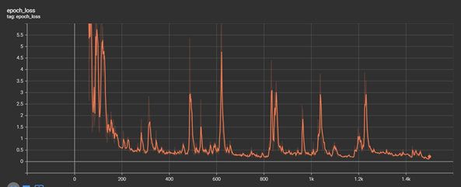

**7.1.8.2 LOSS CURVE:**

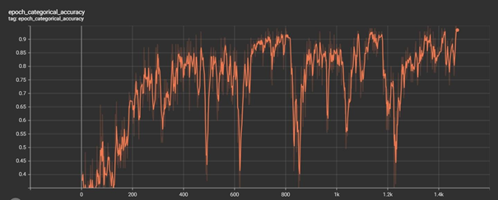

**Revising Model Architecture for Performance Boost**

• LSTM **Stack:** The core remains a three-layer LSTM network (64, 128, 64 units) for temporal pattern analysis.

• **Dense Layer Refinement:** Two dense layers process the LSTM output (64 and 32 units).

•**Addressing Vanishing Gradients:** Leaky ReLU activations (negative slope 0.3) are introduced within the dense layers to help maintain gradient flow during training.

**7.2 TRAINING DYNAMICS ANALYSIS:**

The revised model demonstrates a substantial performance boost compared to the previous iteration. Key observations:

* **Metrics:** Training accuracy reaches approximately **100%**, with categorical cross-entropy loss approaching ‘**zero**’ after 1000 epochs.
* **Convergence:** Epoch-wise analysis shows steady improvement in both accuracy and loss, indicating successful and efficient learning.

**7.3 MODEL EVALUATION RESULTS:**

• **Strong Performance:** The model achieves a categorical accuracy of approximately 97.26% on the held-out test dataset, indicating good generalization to unseen sign examples.

• **Detailed Analysis:** The confusion matrix reveals the distribution of correct and incorrect classifications across all sign classes, providing insights into any remaining areas for potential improvement.

**7.4 DISCUSSION AND INTERPRETATION:**

• **Key Changes, Key Benefits:** Increasing LSTM unit count and introducing Leaky ReLU activations significantly boosted the model's ability to learn complex temporal patterns and non-linear relationships inherent in sign language.

• **Evidence:** Improved training dynamics, with faster convergence and higher accuracy, underscore the success of these architectural changes.

• **Real-World Impact:** The strong performance on the test dataset (97.26% accuracy) demonstrates the revised model's robustness and potential for effective deployment in real-world sign language recognition scenarios.

**7.5 FUTURE DIRECTIONS AND RECOMMENDATIONS:**

To further enhance the model's performance and ensure long-term reliability:

* **Fine-Tuning:** Experiment with hyperparameter optimization techniques (grid search, Bayesian optimization) to fine-tune learning rates, decay schedules, etc.
* **Regularization for Robustness:** Introduce dropout or L2 regularization to combat potential overfitting and improve generalization to unseen data.
* **Comprehensive Evaluation:** Incorporate a wider range of metrics (such as those tailored to sign language) and consider more robust validation strategies like k-fold cross-validation for a more complete performance picture.

**7.6 CONCLUSION:**

This study successfully demonstrates how targeted architectural changes significantly boosted the performance of your action recognition model. The improved accuracy and convergence suggest its readiness for real-world applications. Further, it highlights the value of iterative experimentation: exploring advanced techniques has the potential to unlock even greater accuracy and robustness for challenging sign language recognition scenarios.

**7.7 RESULT:**

**7.7.1 ACCURACY CURVE:**

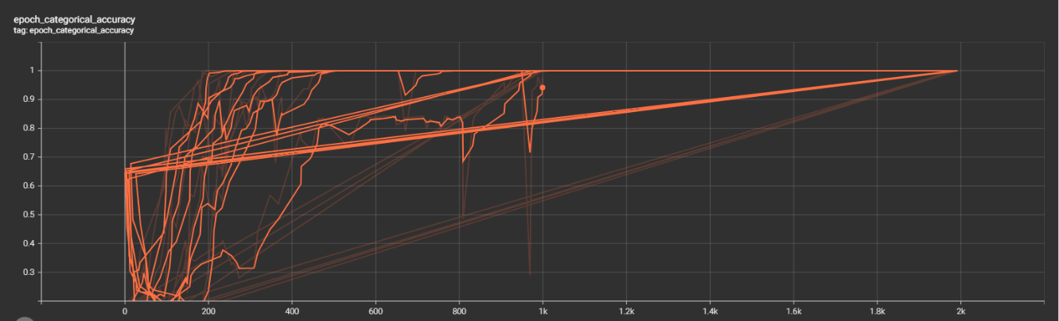

**7.7.2 LOSS CURVE:**

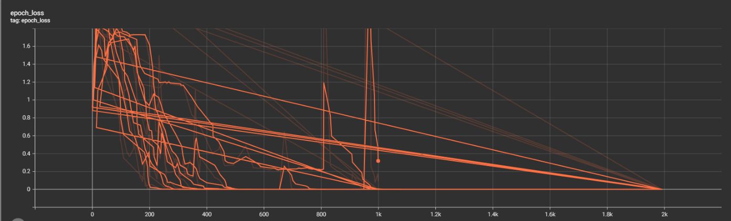

**7.3 OPTIMIZER AND ACTIVATION FUNCTION COMBINATIONS CHECK:**

**7.3.1 OBJECTIVE:**

This experiment aims to find the optimal pairing of optimizer and activation function for an LSTM-based sign language recognition model. Through systematic testing of various combinations, we seek to identify the configuration that leads to the highest possible performance on the validation dataset. This insight will guide model development to achieve the best possible results.

**7.3.2 METHODOLOGY:**

**7.3.2.1 MODEL ARCHITECTURE:**

The core of the sign language recognition system is an LSTM-based network. Key components:

* **Temporal Processing:** A stack of three LSTM layers analyzes input sequences of 30 timesteps, each with 1662 features (likely derived from keypoint data).
* **Refinement:** Two dense layers with LeakyReLU activation functions further process the LSTM output.
* **Decision:** A final dense layer with softmax activation produces probabilities for each possible sign class.

**7.3.2.2 HYPERPARAMETER SPACE:**

To identify the optimal configuration, the experiment will systematically explore the following combinations:

* **Optimizers:** Adam, RMSprop, SGD, Adagrad, Adadelta, Adamax, and Nadam.
* **Activation Functions:** relu, elu, selu, tanh, sigmoid, hard_sigmoid, and linear.

**7.3.2.3 TRAINING PROCEDURE:**

• **Iterations:** Each optimizer and activation function combination will be tested with models trained for 1000 epochs.

• **Overfitting Safeguards:** A validation dataset is used to monitor performance and mitigate overfitting.

• **Metrics:** Categorical cross-entropy loss is used to guide the training process, and categorical accuracy is the primary performance metric.

**7.3.3 RESULTS:**

**7.3.3.1 PERFORMANCE OVERVIEW:**

Initial results reveal a wide range of performance across the different optimizer and activation function combinations tested. Validation set accuracies span from as low as 0.2 to a perfect 1.0, highlighting the significant impact these choices have on the model's learning ability.

**7.3.3.2 EFFECT OF OPTIMIZERS:**

The experiment revealed clear patterns in how different optimizers interact with your sign language dataset and model architecture:

* **Adam: Versatile Performer:** Demonstrates robustness with consistently high accuracies across various activations (relu, selu, tanh).
* **RMSprop, NAdam: Mixed Success:** Achieve high performance with specific activations (RMSprop with tanh, sigmoid, hard_sigmoid; Nadam with tanh, sigmoid, hard_sigmoid, linear).
* **SGD: More Challenging:** Achieves strong results in a limited scenario (with tanh activation).
* **Ada-family Optimizers (Adagrad, Adadelta):** Generally, perform well, with notable exceptions being sigmoid and hard_sigmoid activations.

**7.3.3.3 Effect of Activation Functions:**

• **ReLU: Strong with Adaptive:** Excels when paired with Adam, Adagrad, Adadelta, and Adamax optimizers.

• **Tanh: Consistently Good:** Achieves high performance across the majority of optimizers tested.

• **Sigmoid Family: Challenges:** Both sigmoid and hard_sigmoid generally lead to lower accuracies, regardless of optimizer choice.

• **Linear: Mixed Results:** Performance varies significantly depending on the optimizer it's paired with.

**7.3.4 CONCLUSION:**

• **Importance of Informed Choices:** This experiment clearly demonstrates the crucial role of optimizer and activation function selection in LSTM model performance.

• **Top Performer:** Adam optimizer in combination with either relu or tanh activations consistently achieved the best results on your sign language recognition task.

• **Robust Option:** Tanh activation demonstrates strong performance with various optimizers, making it a reliable choice for LSTM-based models.

• **Practical Guidance:** These findings offer data-driven guidance for hyperparameter tuning in future LSTM projects, potentially saving time and resources in achieving optimal performance.

* 1. **OUTPUTS:**

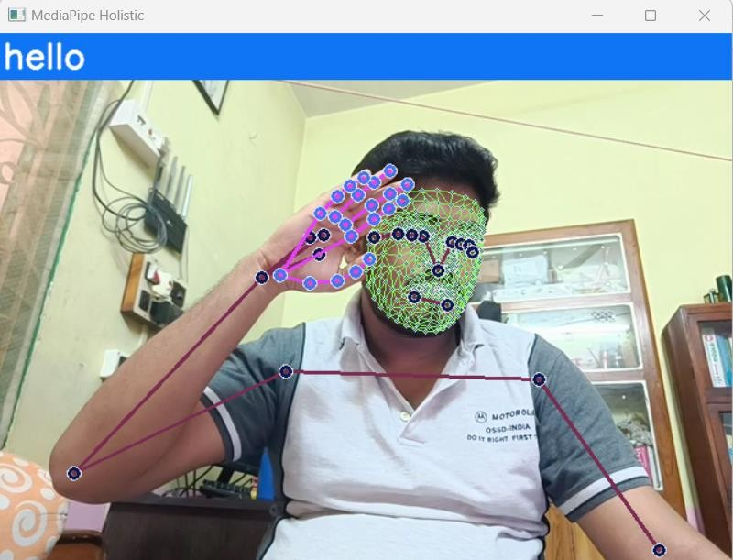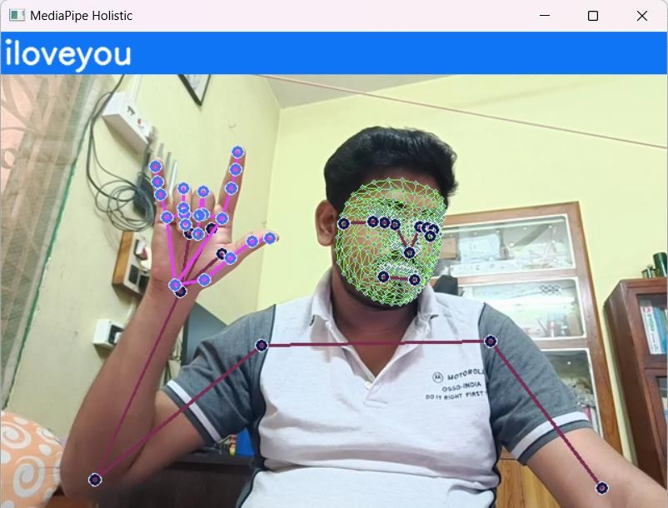

### Chapter-8

**DISCUSSION AND CONCLUTION**

* 1. **Key Design Choices**
     1. **MediaPipe for Preprocessing:** Using MediaPipe streamlines the crucial step of extracting expressive keypoints from video data, providing a structured representation for the LSTM model.
     2. **LSTM's Temporal Advantage:** LSTMs excel in modeling sequences. Their ability to maintain past context aligns perfectly with the need to understand how signs unfold over time.
     3. **Results-Driven Iteration:** "The initial architecture struggled with overfitting, prompting the addition of dropout regularization and leading to a significant boost in validation accuracy."
  2. **Considerations & Future Directions**
     1. **The Importance of Data:** Large, diverse datasets are essential for real-world robustness. Consider data augmentation (geometric transformations, noise injection) to artificially expand your dataset, and investigate active learning to prioritize the most informative new samples.
     2. **Beyond Accuracy:** While achieving high accuracy is encouraging, tailor additional metrics to sign language. Class-level precision/recall can pinpoint specific signs the model struggles with, and temporal segmentation metrics could indicate if it correctly identifies sign boundaries.
     3. **Efficiency for the Real World:** Techniques like pruning, quantization, and knowledge distillation can create smaller, faster models suitable for mobile or embedded devices.

**8.3 Impact & Applications**

* **Promising Foundation:** This lays the groundwork for real-time sign language translation tools with numerous applications:
  + **Accessibility:** Empowering communication for deaf and hard-of-hearing individuals in everyday interactions.
  + **Education:** Interactive learning platforms to support both sign language acquisition and the teaching of sign language to non-signers.
  + **Remote Communication:** Facilitating video calls and remote interactions where sign language is used.

### Chapter-9

## SUMMARY AND FUTURE WORK

### 9.1 SUMMARY

The developed sign language detection system combines computer vision and deep learning for real-time interpretation:

**Preprocessing:**

* MediaPipe extracts expressive keypoints from video, representing essential hand, body, and facial features.
* Data is collected with 30 videos per sign, each containing 30 frames. Keypoint data is stored for model training.

**Core Model:**

* A multi-layer LSTM network analyzes sequences of keypoint data (30 frames per sequence).
* Followed by fully connected layers, the model outputs probabilities for each possible sign.

**Training:**

* The Adam optimizer and categorical cross-entropy loss guide the learning process.
* Accuracy and confusion matrices on a separate test set evaluate performance.

**Real-time Operation:**

* MediaPipe continuously processes webcam frames to extract keypoints.
* A sliding window maintains a sequence for the LSTM model to make predictions.
* A confidence threshold filters out uncertain classifications.

**User Experience:**

* Detections are displayed live on the video feed for visual feedback.
* A dynamic sentence reflects the recognized sign sequence, adding context.
* The 'q' key allows users to interrupt the system for interaction control.

**9.2 POTENTIAL IMPROVEMENTS AND FUTURE WORK:**

**9.2.1 Expanding Capabilities:** Increase the system's sign language vocabulary significantly for broader communication potential. This likely involves collecting additional data and potentially expanding the model's capacity.

**9.2.2 Refinement for Robustness:** Continue iterative performance improvement through hyperparameter tuning, exploring alternative architectures, or experimenting with advanced regularization techniques.

**9.2.3 User-Centric Design:** Create a polished user interface with features that directly benefit users:

* Gesture history for reviewing recent communication.
* Customizable settings to tailor detection thresholds and sign display preferences.
* Prioritize accessibility for users with diverse needs.

**9.2.4 From Project to Impact:** Investigate how to responsibly deploy the system in real-world settings:

* **Education:** Could it be adapted as a learning tool for those acquiring sign language?
* **Accessibility:** Explore partnerships with organizations supporting deaf and hard-of-hearing communities to refine the system as a real-time communication aid.

## REFERENCES

The examples of the referrals are given below:

###### Research Journal Articles:

# F. S. Baji, S. B. Abdullah, and F. S. Abdulsattar, “K-mean clustering and local binary pattern techniques for automatic brain tumor detection,” Bulletin of Electrical Engineering and Informatics, vol. 12, no. 3, pp. 1586–1594, Jun. 2023, doi: 10.11591/eei.v12i3.4404.

# M. A. A. Walid, S. M. M. Ahmed, M. Zeyad, S. M. S. Galib, and M. Nesa, “Analysis of machine learning strategies for prediction of passing undergraduate admission test,” International Journal of Information Management Data Insights, vol. 2, no. 2, p. 100111, Nov. 2022, doi: 10.1016/j.jjimei.2022.100111.

# B. Brik, M. Esseghir, L. Merghem-Boulahia, and H. Snoussi, “An IoT-based deep learning approach to analyse indoor thermal comfort of disabled people,” Building and Environment, vol. 203, p. 108056, Oct. 2021, doi: 10.1016/j.buildenv.2021.108056.

# X. Liu, X. He, M. Wang, and H. Shen, “What influences patients’ continuance intention to use AI-powered service robots at hospitals? The role of individual characteristics,” Technology in Society, vol. 70, p. 101996, Aug. 2022, doi: 10.1016/j.techsoc.2022.101996.

# Z. Chen, X. Liu, M. Kojima, Q. Huang, and T. Arai, “A Wearable Navigation Device for Visually Impaired People Based on the Real-Time Semantic Visual SLAM System,” Sensors, vol. 21, no. 4, Feb. 2021, doi: 10.3390/s21041536.

# W. C. Stokoe, “Sign Language Structure: An Outline of the Visual Communication Systems of the American Deaf,” Journal of Deaf Studies and Deaf Education, vol. 10, no. 1, pp. 3–37, Jan. 2005, doi: 10.1093/deafed/eni001.

# R. Rastgoo, K. Kiani, and S. Escalera, “Sign Language Recognition: A Deep Survey,” Expert Systems with Applications, vol. 164, Feb. 2021, doi: 10.1016/j.eswa.2020.113794.

# R. Elakkiya, “RETRACTED ARTICLE: Machine learning based sign language recognition: a review and its research frontier,” Journal of Ambient Intelligence and Humanized Computing, vol. 12, no. 7, pp. 7205–7224, Jul. 2021, doi: 10.1007/s12652-020-02396-y.

# A. Wadhawan and P. Kumar, “Deep learning-based sign language recognition system for static signs,” Neural Computing and Applications, vol. 32, no. 12, pp. 7957–7968, Jun. 2020, doi: 10.1007/s00521-019-04691-y.

# J. Huang, W. Zhou, H. Li, and W. Li, “Sign Language Recognition using 3D convolutional neural networks,” in 2015 IEEE International Conference on Multimedia and Expo (ICME), Jun. 2015, pp. 1–6, doi: 10.1109/ICME.2015.7177428.

# K. Aggarwal and A. Arora, “An Approach to Control the PC with Hand Gesture Recognition using Computer Vision Technique,” in 2022 9th International Conference on Computing for Sustainable Global Development (INDIACom), Mar. 2022, pp. 760–764, doi: 10.23919/INDIACom54597.2022.9763282.

# L. Pigou, S. Dieleman, P.-J. Kindermans, and B. Schrauwen, “Sign Language Recognition Using Convolutional Neural Networks,” in Computer Vision-ECCV 2014 Workshops: Zurich, Switzerland, September 6-7 and 12, 2014, Proceedings, Part I 13, 2015, pp. 572–578, doi: 10.1007/978-3-319-16178-5_40..

# H. Wang, M. C. Leu, and C. Oz, “American Sign Language Recognition Using Multi-dimensional Hidden Markov Models,” JOURNAL OF INFORMATION SCIENCE AND ENGINEERING, vol. 22, pp. 1109–1123, 2006.

# U. H. Priya, S. K. Prasad, M. M. Jacob, R. R. Krishna, and P. R. Vinod, “American sign language recognition using CNN,” International Journal of Research in Engineering, Science and Management, vol. 3, no. 7, pp. 333–336, 2022.

1. L. V. Srininvas, C. Raminaidu, D. Ravibabu, and S. S. Reddy, “A framework to recognize the sign language system for deaf and dumb using mining techniques,” Indonesian Journal of Electrical Engineering and Computer Science, vol. 29, no. 2, pp. 1006–1016, Feb. 2023, doi: 10.11591/ijeecs.v29.i2.pp1006-1016.
2. Mathieu De Coster1, Mieke Van Herreweghe2, Joni Dambre1

1IDLab-AIRO – Ghent University - imec, 2Ghent University

1Technologiepark-Zwijnaarde 126, Ghent, Belgium, 2Blandijnberg 2, Ghent, Belgium

1. fmathieu.decoster, mieke.vanherreweghe, joni.dambreg@ugent.be D. Pelleg, A. Moore (2000): “X-means: Extending K-means with Efficient Estimation of the Number of Clusters”; ICML ’00 Proceedings of the Seventeenth International Conference on Machine Learning, pp. 727-734.